**Name:-** Gaurang A Raorane **Div:-** D15A

**Roll No:-** 49 **Batch:-** C

**EXPERIMENT 4**

Aim - To install Kubectl and execute Kubectl commands to manage the Kubernetes cluster and deploy Your First Kubernetes Application.

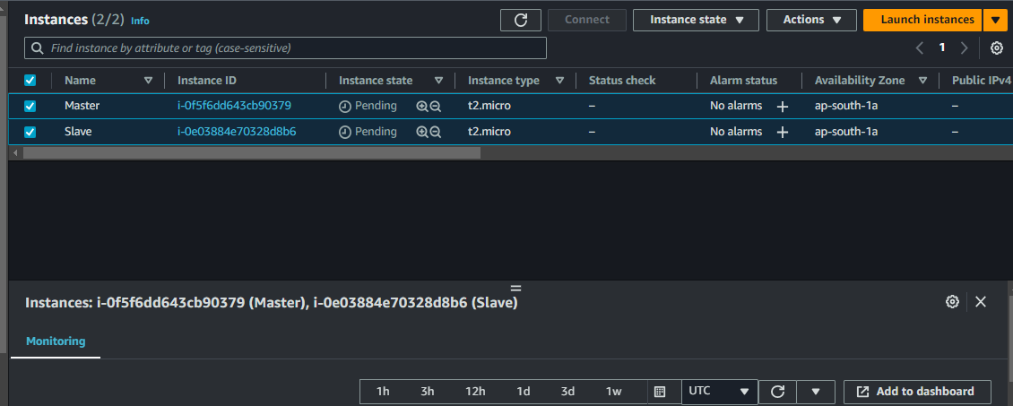









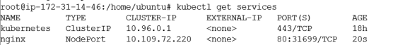

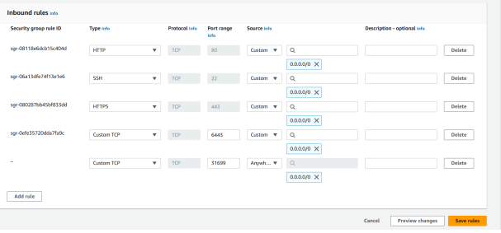

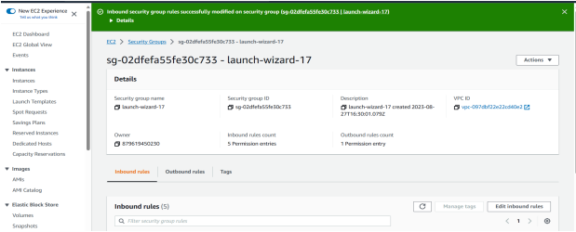

On worker node-

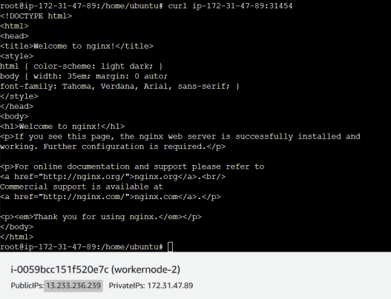

On worker node -

